LAB REPORT FOR CODING STANDARS

SOFTWARE ENGINEERING II

ALEX VILLEGAS

PAO II 2023

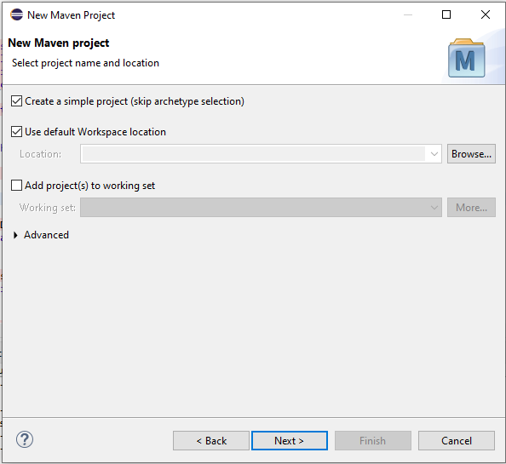First, we start creating a new maven single project in eclipse.

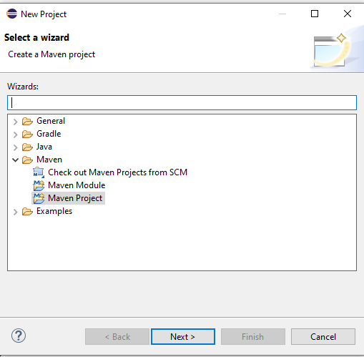

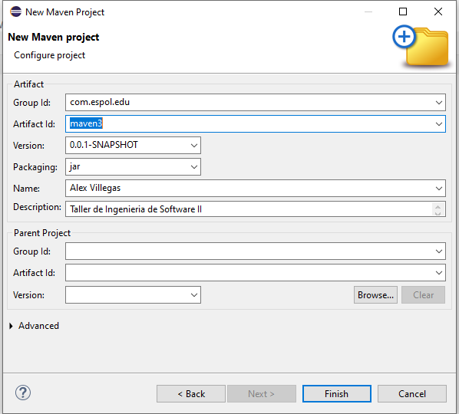

Then, we generate the code according to the user requirements of the workshop.

**package** maven3;

**public** **class** Vacation {

**private** String destination;

**private** **int** travelers;

**private** **int** duration;

**private** **int** base_cost = 1000;

**private** **double** total_cost = 0;

**public** Vacation() {

}

**public** String getDestination() {

**return** destination;

}

**public** **void** setDestination(String destination) {

**this**.destination = destination;

}

**public** **int** getTravelers() {

**return** travelers;

}

**public** **void** setTravelers(**int** travelers) {

**this**.travelers = travelers;

}

**public** **int** getDuration() {

**return** duration;

}

**public** **void** setDuration(**int** duration) {

**this**.duration = duration;

}

**public** **int** getBase_cost() {

**return** base_cost;

}

**public** **void** setBase_cost(**int** base_cost) {

**this**.base_cost = base_cost;

}

**public** **double** getTotal_cost() {

**if** (total_cost == 0){

**return** -1;

}

**return** total_cost;

}

**public** **void** setTotal_cost(**double** total_cost) {

**this**.total_cost = total_cost;

}

**public** **double** verifyDestiny(String destination) {

**int** additional = 0;

**if**(destination.toUpperCase().equals("Paris")) {

additional = 500 + **this**.base_cost;

}

**else** **if**(destination.toUpperCase().equals("New York City")) {

additional= 600 + **this**.base_cost;

}

**return** additional + **this**.base_cost;

}

**public** **void** getCost(**double** totalcost, **int** travelers, **int** duration) {

**double** discount = 0;

**double** fee = 200;

**if**(travelers>4 && travelers <10) {

discount = total_cost*0.10;

**this**.total_cost = totalcost - discount;

}

**if**(travelers>10) {

discount = total_cost*0.20;

**this**.total_cost = totalcost - discount;

}

**if**(duration<7) {

**this**.total_cost = totalcost + fee;

}

**if**(duration>30 || travelers == 2) {

**this**.total_cost = totalcost - fee;

}

**else** {

**this**.total_cost = **this**.base_cost;

}

}

}

**package** maven;

**import** java.util.Scanner;

**public** **class** VacationEstimator {

//CHECKSTYLE:OFF

**public** **static** **void** main(String[] args) {

//CHECKSTYLE:ON

Vacation vac1 = **new** Vacation();

Scanner sc = **new** Scanner(System.***in***);

System.***out***.println("*****Vacation Package Estimator*****");

System.***out***.println("Enter your destination:");

vac1.setDestination(sc.nextLine());

System.***out***.println("Enter the number of travelers:");

vac1.setTravelers(sc.nextInt());

System.***out***.println("Enter the duration in days:");

vac1.setDuration(sc.nextInt());

**if**(vac1.getTravelers()>80) {

System.***out***.println("The vacation package is not available for groups of more than 80 persons");

}

**else** {

**double** total_cost = vac1.verifyDestiny(vac1.getDestination());

vac1.getCost(total_cost, vac1.getTravelers(), vac1.getDuration());

System.***out***.println("The total cost of the vacation package is " + vac1.getTotal_cost());

}

}

}

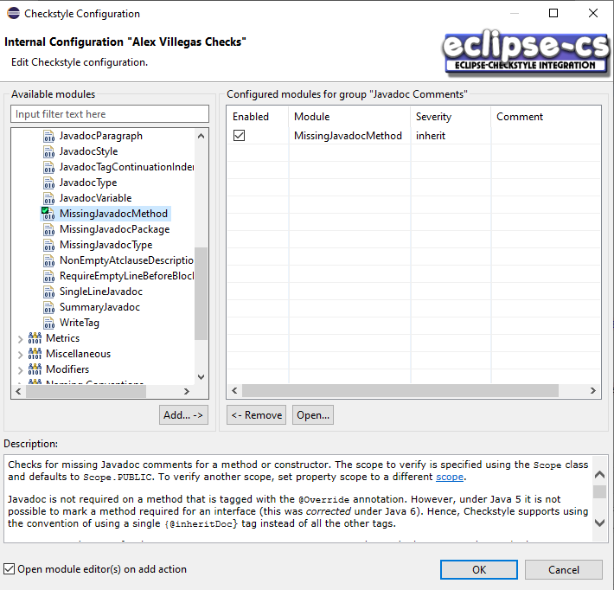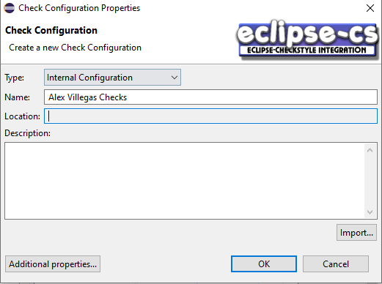We proceed to configure the checkstyle for our project.

Then, we configure the checkstyle with XML adding the rules presented in the guide and 6 new rules.

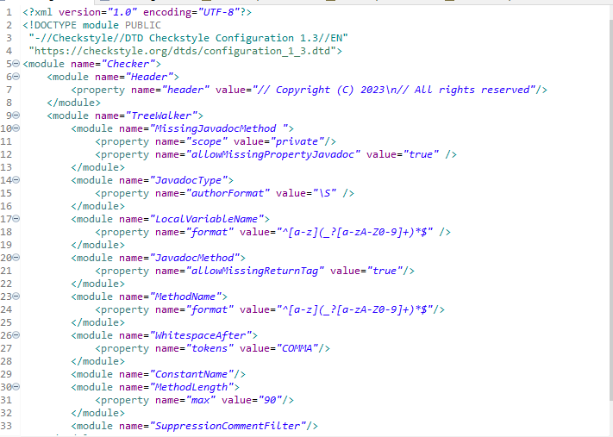

We add the “SupressionCommentFilter” rule to our configuration file.

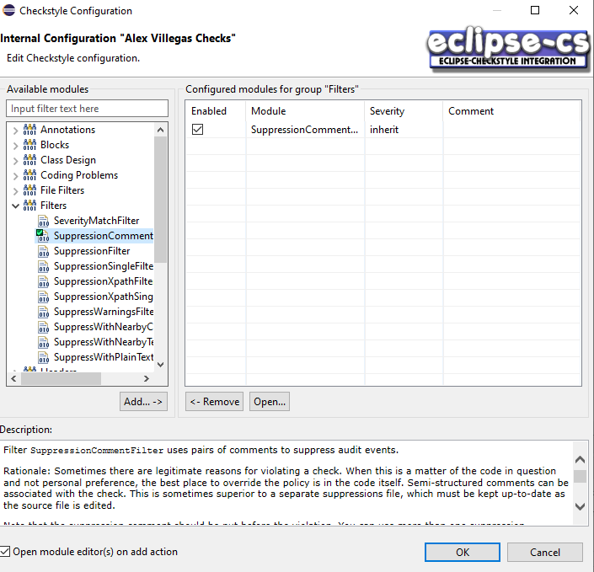

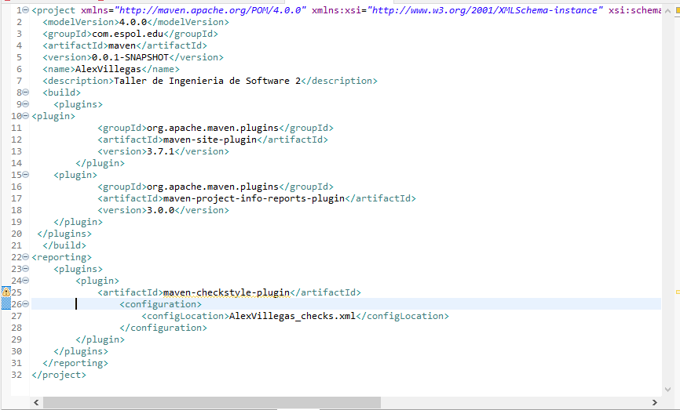We set up the basic configuration of your pom.xml, adding some configurations given in the guide.

Then, we run the pom.xml archive as “maven build…”, set the goal as “site”, and wait for the corresponding report of the results.

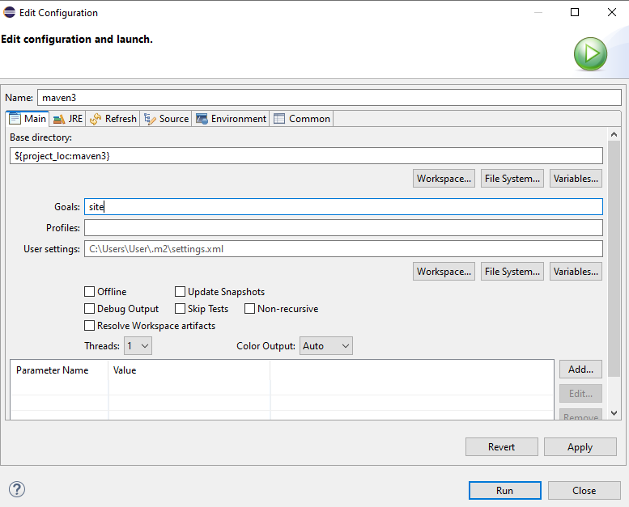

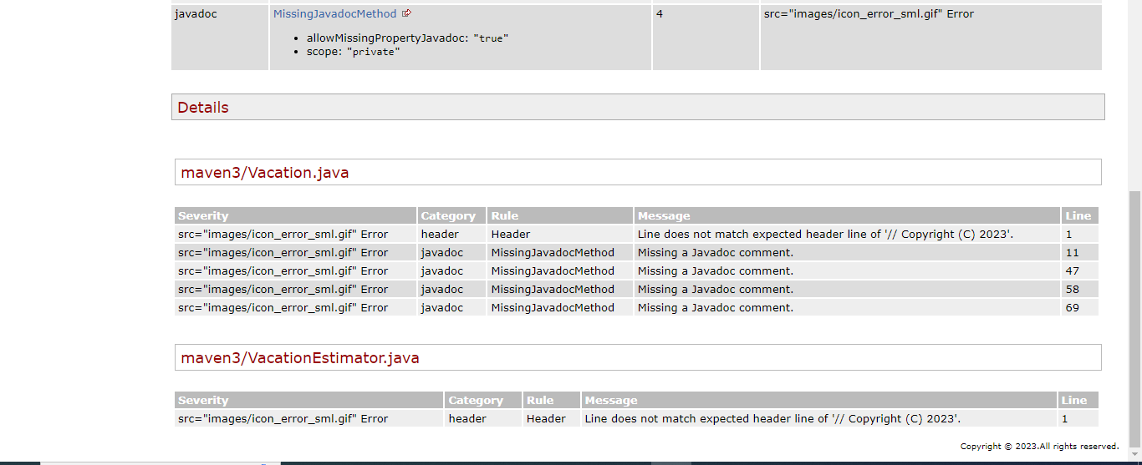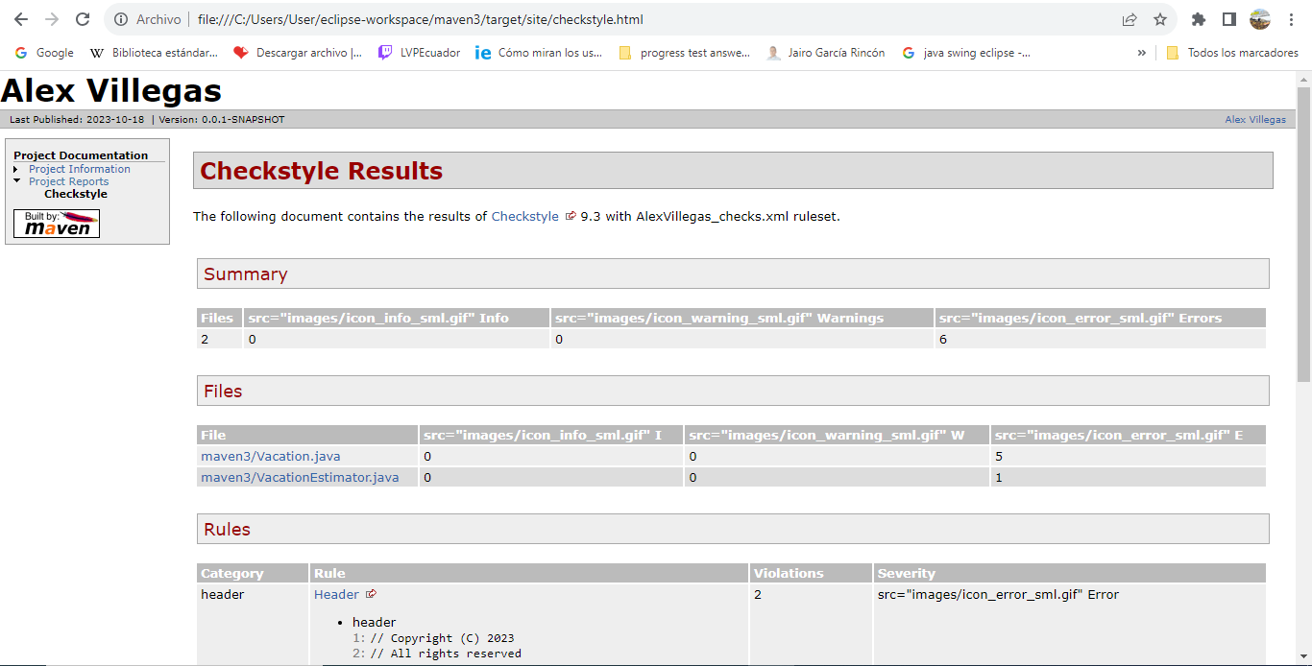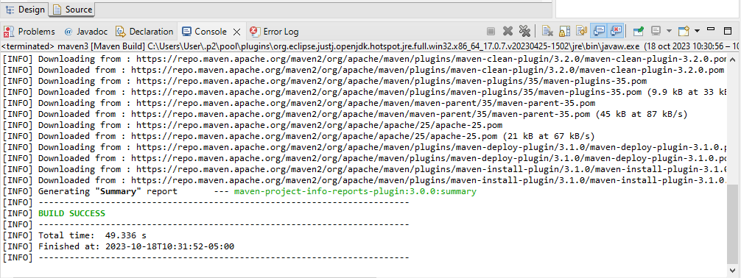

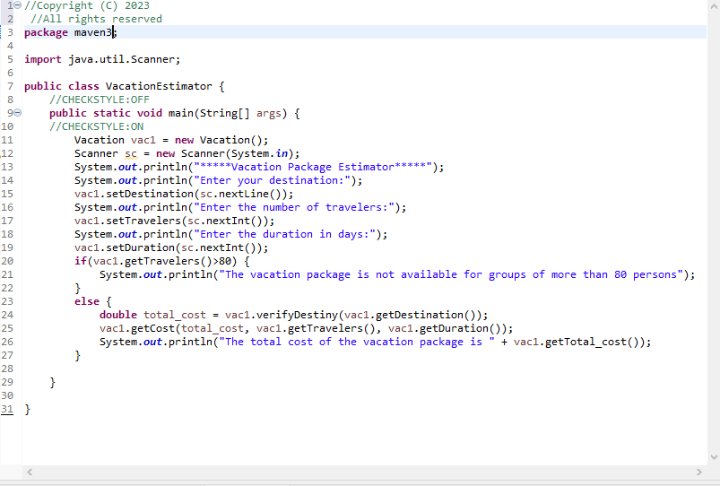After the report is done, we can see that wee have some errors that we must correct and at what type of error we are fighting. So, we proceed to resolve it.

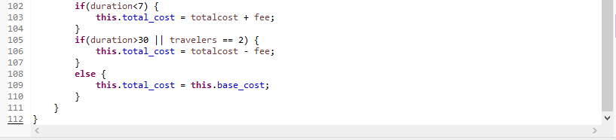

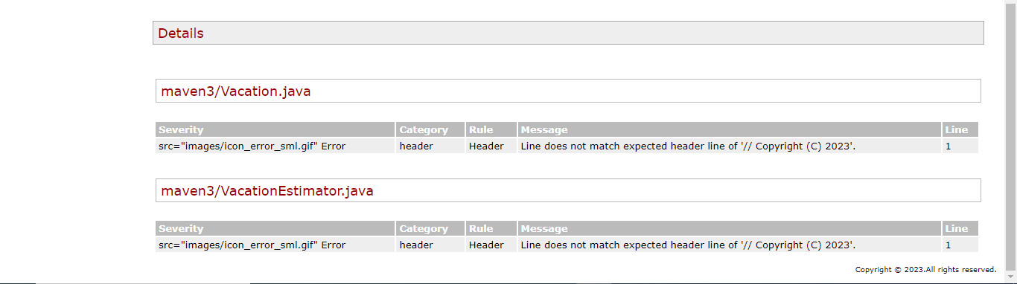Having fixed totally or partial the errors, we run again the pom.xml file to see if in the report the errors were fixed or not.

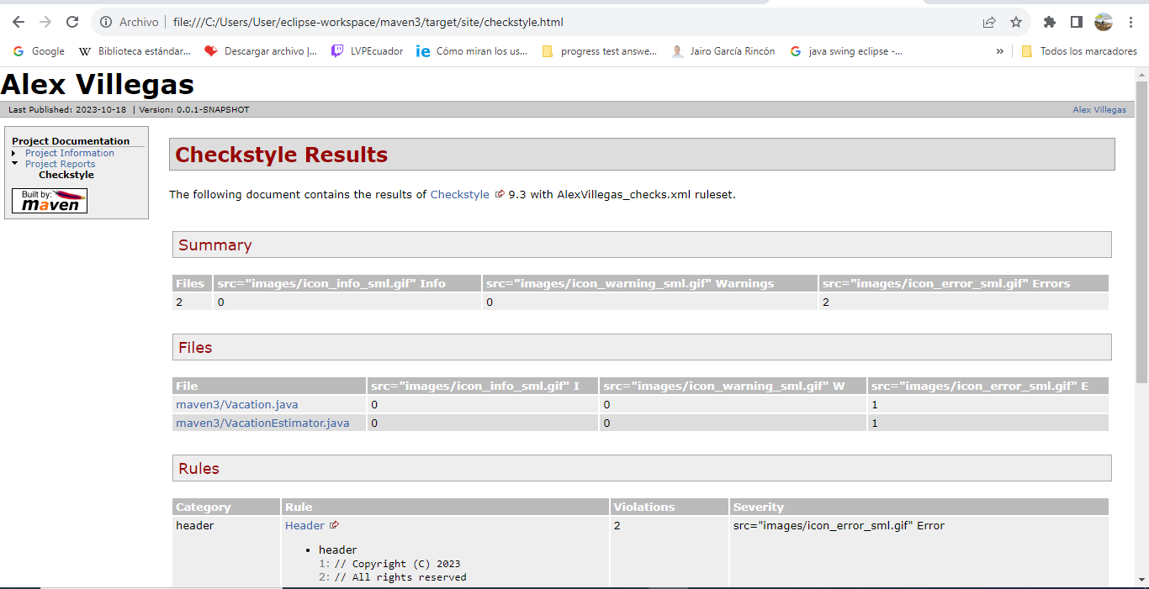

Despite what comes out in the report, we have fixed most of the bugs, the major ones, which means that our code style is better.

# Extra:

For our project of the subject, we simulate a similar process using a different codding standard tool. The tool that we use in this case is “eslint JavaScript”, it is used for JavaScript files.

First, install the required packages for ESLint, JavaScript, and follow the necessary steps to configure them.

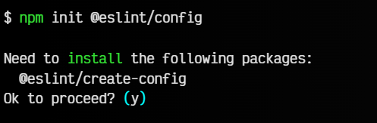

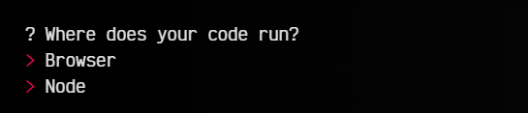

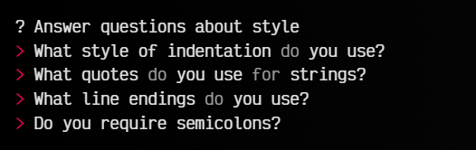

Afte that, a file called ".eslintrc.js" is automatically created in our project with the following structure:

module.exports = {

'env': {

'browser': true,

'es2021': true,

'node': true

},

'extends': [

'eslint:recommended',

'plugin:react/recommended'

],

'overrides': [

],

'parserOptions': {

'ecmaVersion': 'latest',

'sourceType': 'module'

},

'plugins': [

'react'

],

'rules': {

'indent': [

'error',

2

],

'linebreak-style': [

'error',

'windows'

],

'quotes': [

'error',

'double'

],

'semi': [

'error',

'always'

]

}

};

Finally, we run the commad “npx eslint src” in a new terminal in the root of the project.

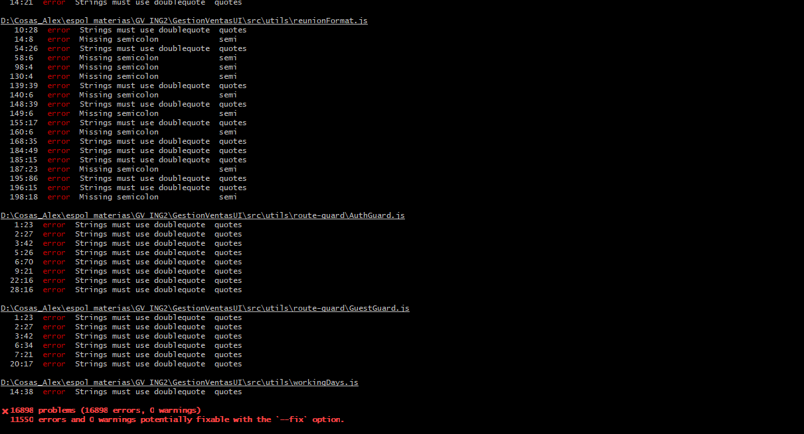ESLint will lint all JavaScript compatible files within the current folder and will output the results to your terminal.

Having that report in our terminal, we will identify which are the errors that are presented in our project, and now we can start to fix those errors based on the report either automatically with the command “npx eslint --fix src” or manually.

# Resources:

***Link of the public repository:*** https://github.com/ajvilleg10/WorkshopCodingStandar